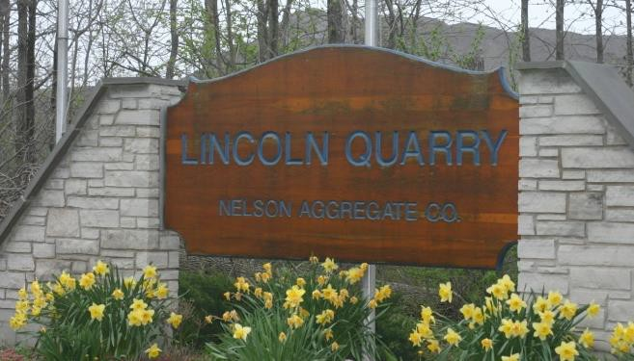

***NO children under 16 are allowed and full PPE is required. Waivers will be signed on site. Directions to Quarry Below***

***Dating***

Middle Silurian Period, Late Wenlock (Silurian 443.8±1.5 to 419.2±3.2 Ma - Late Wenlock ~433-427 Ma)) (Niagara Escarpment) minerals and fossils.

***Strata***

Lockport Group - erosionally resistant dolostones (dolomite) with a predominance of carbonates formed in shallow marine conditions. Eramosa, Goat Island, & Gasport Formations - each formation contains distinctive fossil reefs.

***Nelson Aggregate Co - Lincoln Quarry***

*5362 Young Street, Beamsville, Ontario*

***Saturday May 10, 2025***

**9:00 AM to 4:00 PM**

***Field Trip Leader: Don Lapham***

email is: [xtaldon@gmail.com](mailto:xtaldon@gmail.com)

**716 438 3794**

*Please arrive by 8:30 am for Safety Talk.*

*Entry to the quarry approx 9:00 am.*

*Sign-in & Sign-out procedures, tags for cars, and*

***FULL SAFETY GEAR*** *(this is a working quarry)***See Below\*\*\**

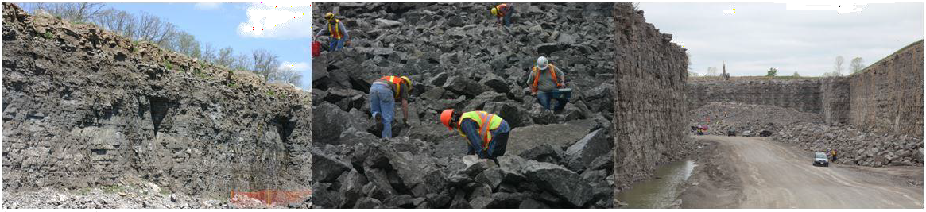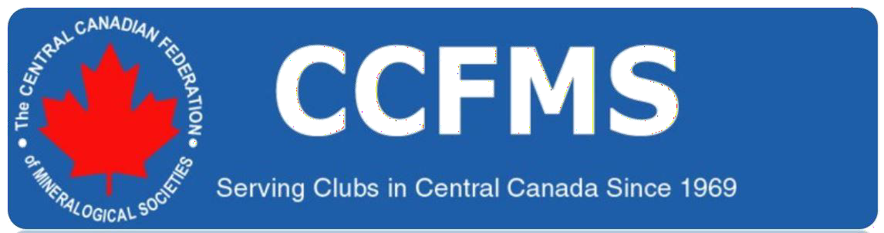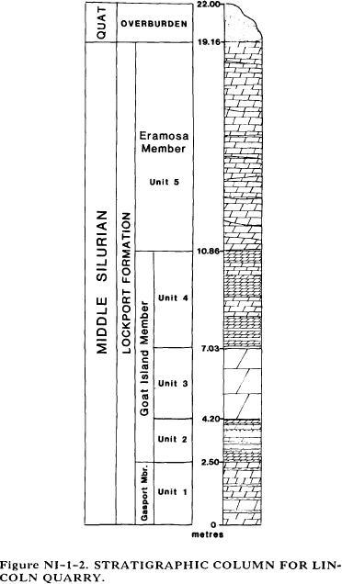

*Pictures by P Anderson, NPGS, May 2009, May 2011, 2013*

Latitude & Longitude (Decimal Degrees): 43.884503, -78.699519

***Geology***

[*http://www.geologyontario.mndm.gov.on.ca/mndmfiles/MDI/data/records/MDI30M03SW00009.html*](http://www.geologyontario.mndm.gov.on.ca/mndmfiles/MDI/data/records/MDI31C05NE00018.html)

Lincoln Quarry exposes Lockport Formation rocks consisting of Eramosa, Goat Island, and Gasport Members.

•

•

Eramosa Formation is brown, fine crystalline, medium-bedded bituminous dolostone with large vugs lined with calcite crystals. Goat Island Formation is a fine to medium-crystalline, thin to massive-bedded brown dolostone, bituminous, and richly fossiliferous

-

gypsum, sphalerite, calcite, dolomite, and chert mineralization are abundant.

•

Gasport Formation, present in the sump, is a light brown-buff, fine crystalline dolostone with sphalerite, gypsum, and calcite mineralization.

[*Limestone Industries of Ontario Volume III Limestone Industries and Resources of Central and Southwestern Ontario Prepared for the*](http://www.geologyontario.mndmf.gov.on.ca/mndmfiles/pub/data/imaging/NSP003A/NSP003A.pdf)[*Aggregate Resources Section, Land Management Branch, Ontario Ministry of Natural Resources; Derry Michener Booth and Wahl &*](http://www.geologyontario.mndmf.gov.on.ca/mndmfiles/pub/data/imaging/NSP003A/NSP003A.pdf)[*Staff of the Engineering and Terrain Geology Section, Ontario Geological Survey, Ministry of Northern Development and Mines; 1989*](http://www.geologyontario.mndmf.gov.on.ca/mndmfiles/pub/data/imaging/NSP003A/NSP003A.pdf)

*Geological Section*

*UNIT 5 Lockport Formation, Eramosa Member*

*Thickness*

*8.30 m*

Dolostone: brown, weathers brown; fine crystalline; medium bedded (8 to 30 cm), contacts are sharp, slightly undulatory and irregular; calcite crystals rim large vugs (up to 1.5 m in diameter), selenite in pores and vugs; bituminous odor; porous; bryozoa are abundant; stylolitic and bituminous partings present; lower contact is floor of lift #1.

*UNIT 4 Lockport Formation, Goat Island Member*

*3.83 m*

Dolostone: dark grey, weathers grey; sub- to fine and medium

crystalline; thin to medium bedded (4 to 15 cm), contacts are sharp and planar; gypsum occurs along fractures, calcite in vugs and pores, dolomite in contorted vugs - some in fractures, red/yellow sphalerite occurs as small nodules; crinoids and brachiopods are abundant as fragments, corals are rare; shaly and silty partings at base with shale rip-ups within the dolostone; the character of the rock changes gradually in the upper 1.40 m to a finer crystalline rock with abundant bituminous stylolites; rock has a lithographic texture; lower contact is sharp, with a 3 cm thick shaly parting.

*UNIT 3 Lockport Formation, Goat Island Member*

*2.83 m*

Dolostone: dark brown, weathers light brown; fine crystalline; massive bedded; stylolitic; calcite in pores, gypsum in fractures and scattered sphalerite mineralization; large stromatoporoids present, abundant algal material in up per part; the upper third of the unit is highly fractured and mineralized; lower contact is sharp.

*UNIT 2 Lockport Formation, Goat Island Member*

*1.70 m*

Dolostone: dark brown, weathers black-brown; very fine to fine crystalline; thin to medium bedded (4 to 15 cm), sharp contacts with bituminous partings and stylolites; chert, calcite, gypsum and abundant tabulate corals (which can occur in lateral sheets), rare solitary corals, abundant bioturbation *(Chondrites);* bituminous partings present; chert occurs as beds (3 cm thick), black in colour and rimmed with bituminous material; base of unit is quarry floor.

*UNIT 1 Lockport Formation, Gasport Member (in sump)*

*2.5 m*

Dolostone: light brown-buff, weathers tan; fine crystalline; medium to thick bedded, contacts are sharp with black, bituminous partings, some are stylolitic; sphalerite occurs in fractures and on laminae; gypsum, calcite, dolomite and chert (black and tan) mineralization are also pre sent; stromatoporoids and tabulate corals are present; darker laminae occur with bituminous partings.

*19.16 m*

*Total thickness*

|  |
| --- |
|  |



***Directions to Nelson Aggregate Co - Lincoln Quarry***

*5362 Young Street, Beamsville, Ontario*

Latitude & Longitude: 43°06'38.66"N 79°29' 29.39"W

Latitude & Longitude (Decimal Degrees): 43.110739, -79.491497

Exit the QEW at Ontario Street (exit 64) (Beamsville). Go south on Ontario Street into downtown Beamsville.

At the corner of Ontario and King Streets, turn east (left) onto King Street.

A short distance later – almost immediately – turn south (right) onto Mountain Road. Drive south along Mountain Road - past Fly Road (4-way stop - 3.5 km) - to Yonge Street Turn west (right) onto Yonge Street.

A short distance later, you will see the Lincoln Quarry gate on your left (south) (and probably, other participants). Turn left into the gate and park.

**Mandatory PPE**

**High visibility safety apparel** must have fluorescent stripes with an X on the back.

**Hard Hats** must have retro reflective stripes on the front and back of the head gear as well as both sides to provide 360o reflectivity.

**Safety Footwear** must be a minimum of 6” high, CSA approved (green triangle found on boot), steel toed/protective capped.

**Safety Glasses** with side shields or goggles.

**Long pants**, no shorts.

**Gloves**. The broken rocks are very sharp.

**Extra Notes**

There is little to no shade available. Bring the appropriate sun protection as well as plenty of water. Please do not bring carpenters hammers (claw hammers) as they are not designed to break rock. All participants must be a member of a CCFMS affiliated club to participate in this field trip for liability insurance reasons. Membership cards must be available on request. US attendees must also be a member of a Canadian CCFMS affiliated club.

***Additional Information***

[*Welcome to Nelson Aggregates Locations - Lincoln Quarry (commercial website)*](http://www.nelsonaggregate.com/locations.php?id=4)

***Sources:***

Goodman, William - Late Ordovician and Silurian Strata of the Niagara Region: An economic and historical geology overview (1969) Sabina, Ann P - Rocks and Minerals for the Collector, Bancroft-Parry Sound area and southern Ontario, Geological Survey of Canada (1986)

Alward, Allen - Personal Communication (1990)

Armstrong, D K & Dodge, J E P - Paleozoic Geology of Southern Ontario, Ontario Geological Survey (2007) McKenzie, S R - Stratigraphy of the Salina Group, USGS (2008)



*Pictures by P Anderson, NPGS, May 2009, May 2011, 2013*

***Nelson Aggregate Co - Lincoln Quarry***

*5362 Young Street, Beamsville, Ontario*

***Saturdays usually May (spring) & Sept/Oct (fall) trips Field Trip Leader: Matt Ridley***

email is: [*mrmineralogy@gmail.com*](mailto:mrmineralogy@gmail.com)

*Please arrive by 8:30 am for Safety Talk.*

*Entry to the quarry approx 9:00 am.*

*Sign-in & Sign-out procedures, tags for cars, and*

***FULL SAFETY GEAR*** *(this is a working quarry).*

[*https://www.mindat.org/loc-7831.html*](https://www.mindat.org/loc-7831.html)

anhydrite, barite, calcite, celestine, 'chert', dolomite, fluorite, galena, gypsum *var* selenite, magnetite, marcasite, pyrite, quartz, sphalerite

Tim Jokela, [*London Gem & Mineral Club*](http://www.ccfms.ca/clubs/lgms/)

carbonates - calcite, dolomite

sulphates - barite, celestite, gypsum (*var* selenite)

sulphides - galena, marcasite, pyrite, sphalerite

halides - fluorite

***Comments:***

oxides - magnetite other - fossils (coral), hydrocarbons

Dolomite (when macrocrystalline) is whitish or pinkish with unusual tiny saddle-shaped crystals (made of small misaligned blocks that produce curved crystal faces).

Sphalerite usually appears a gemmy yellow colour (generally, lighter than Dundas Quarry sphalerite) though deeper reds can also be found.

Barite is very white and platy when crystallized.

Very sharp octahedral galena crystals have been found.

Vugs with nice associations of galena, barite, marcasite and dolomite occur. Most crystals are small and suitable for micro-mounts.